PROJECT PLANNING DOCUMENT
Automated Network Request Management
in ServiceNow

Agile Sprint Planning, Backlog & Velocity Report
Prepared: July 2026

1. Project Overview
Automating network request management in ServiceNow enhances operational efficiency by streamlining workflows, reducing manual interventions, and ensuring real-time updates.
The objective of this project is to implement a fully automated and scalable network change management process in ServiceNow that automates user-initiated network requests, ensures rapid fulfillment, maintains audit-ready change records, and provides accurate configuration tracking.

Key Objectives
- Automate the end-to-end lifecycle of user-initiated network requests.
- Eliminate manual, paper-based approval and fulfillment steps.
- Ensure real-time status visibility for requesters and approvers.
- Maintain audit-ready change records for compliance and governance.
- Achieve accurate, automated configuration tracking through CMDB integration.

2. Agile Planning Terminology
The project backlog and sprint plan in this document follow standard Agile/Scrum planning terminology, defined below.
Sprint — A fixed period or duration in which the team works to complete a defined set of tasks from the product backlog.
Epic — A large body of work or project objective that is too big to complete in a single sprint. It is broken down into smaller, manageable stories delivered across multiple sprints.
Story — A small, well-defined unit of work that delivers value to the end user. Each story belongs to a parent Epic.
Story Point — A relative number representing the effort required to complete a story, typically estimated using the Fibonacci sequence (1, 2, 3, 5, 8 ...).

Story Point Scale Used
- 1 — Very Easy task
- 2 — Normal task
- 3 — Moderate task
- 5 — Difficult task

3. Project Backlog & Sprint Planning
The project backlog is organized into six Epics delivered across three sprints. Each Epic is decomposed into user stories, with effort estimated in story points.

Sprint 1
User Story No. | User Story | Story Points
EPIC 1 — Requirement Gathering & Analysis
USN1 | Gather business requirements for network request automation | 3
USN2 | Identify stakeholders and approval hierarchy | 2
USN3 | Analyze existing manual network request process | 3
EPIC 2 — ServiceNow Environment Setup
USN4 | Set up ServiceNow developer / sandbox instance | 2
USN5 | Configure roles, groups and access permissions | 3
USN6 | Enable Change Management and CMDB modules | 2
Total Story Points in Sprint 1 |  | 15

Sprint 2
User Story No. | User Story | Story Points
EPIC 3 — Workflow Automation Design
USN7 | Design network change request approval workflow | 5
USN8 | Create network request catalog item in Service Catalog | 3
USN9 | Design notification and escalation triggers | 2
EPIC 4 — Automation Development
USN10 | Build Flow Designer automation for request routing | 5
USN11 | Integrate CMDB for configuration tracking | 5
Total Story Points in Sprint 2 |  | 20

Sprint 3
User Story No. | User Story | Story Points
EPIC 5 — Testing & Validation
USN12 | Perform unit testing of automated workflows | 3
USN13 | Conduct User Acceptance Testing (UAT) | 3
USN14 | Fix identified defects and issues | 2
EPIC 6 — Deployment & Audit Readiness
USN15 | Deploy solution to production instance | 3
USN16 | Generate audit-ready change record reports | 3
USN17 | Prepare user training documentation | 2
Total Story Points in Sprint 3 |  | 16

4. Sprint-wise Story Point Distribution
The chart below summarizes the total story points completed in each sprint against the team's average velocity.
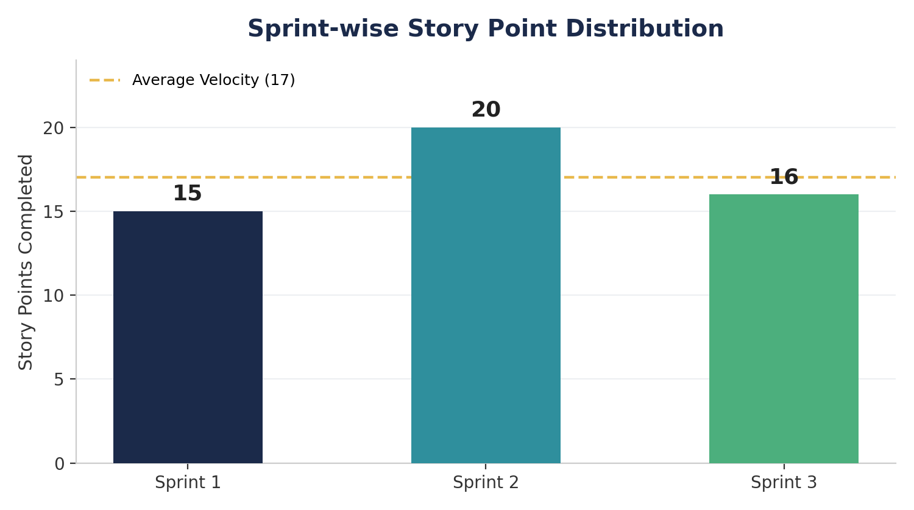
Figure 1: Story points completed per sprint

5. Team Velocity Calculation
Velocity measures the average amount of work, in story points, a team completes per sprint. It is calculated as follows:
Velocity = Total Story Points Completed / Number of Sprints
Total Story Points = 15 (Sprint 1) + 20 (Sprint 2) + 16 (Sprint 3) = 51
Number of Sprints = 3
Velocity = 51 / 3 = 17 Story Points per Sprint
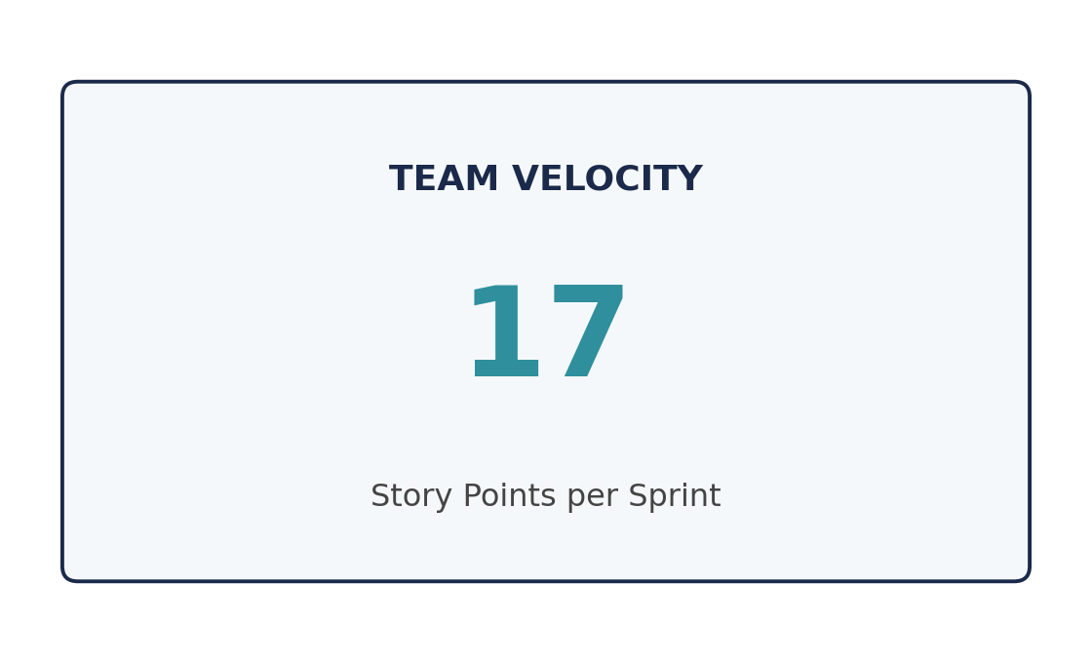
Figure 2: Team velocity summary

6. Automated Network Request Workflow
The diagram below illustrates the target end-to-end automated flow that this project implements in ServiceNow, from request submission through to audit-ready record generation.
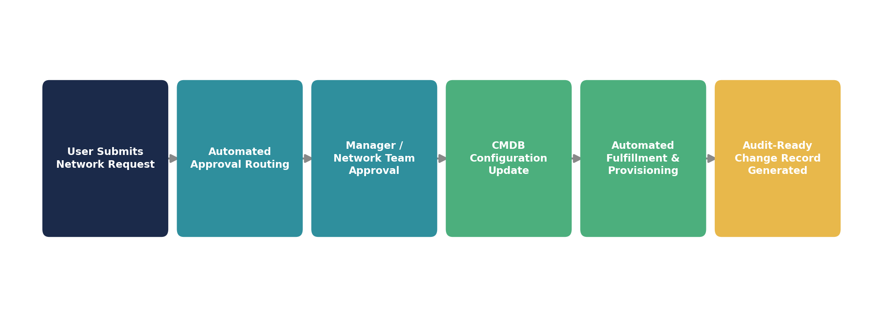
Figure 3: Automated network request management workflow in ServiceNow

7. Conclusion
Based on the sprint plan above, the team's projected velocity of 17 story points per sprint provides a reliable baseline for forecasting subsequent releases of the Automated Network Request Management solution.
Completing the backlog defined in Sprints 1 through 3 will deliver a fully automated, scalable, and audit-ready network change management process within ServiceNow, directly fulfilling the project's stated objective of streamlining workflows, reducing manual interventions, and ensuring real-time updates.

